AUTOMATED DEFORESTATION DETECTION VIA FINE-TUNED RESNET-50 ARCHITECTURE ON SENTINEL-2 SATELLITE IMAGERY
Piyush Manna
Department of Computer Science, Bal Kalyan Vidhya Mandir, Biratnagar, Nepal
Correspondence email: w3bpiyush@gmail.com

ABSTRACT— Rapid deforestation calls for efficient, scalable, and automated ways to monitor changes in land cover. Manual satellite image analysis takes time and resources, making it difficult to track changes promptly. This study presents a lightweight deep learning framework based on a pre-trained ResNet-50 model, adapted through transfer learning using the EuroSAT RGB dataset, which contains 27,000 images across 10 land cover classes. The model was trained in two stages. First, the backbone was frozen to extract features. The entire model was then fine-tuned to improve its classification performance. The approach was applied to a regional, multi-temporal Sentinel-2 satellite dataset covering two timeframes. A grid of 160 spatial patches was evaluated to detect transitions from forest to non-forest land cover. The model achieved an overall test accuracy of 98.52% on unseen evaluation data. During spatial change detection, it identified 2 deforested patches while filtering out changes caused by seasonal crop rotation. Independent validation against Global Forest Watch tree cover loss data showed a high level of spatial agreement with official monitoring baselines. The results indicate that a fine-tuned convolutional neural network can support accurate, accessible, and reproducible environmental monitoring, offering a practical approach to automated land cover assessment and deforestation tracking.

Index Terms— Deforestation Detection, Deep Learning, Sentinel-2, ResNet-50, Remote Sensing, Land Cover Classification.

I. INTRODUCTION
Forest ecosystems play an important role in maintaining environmental stability. They help regulate the climate, absorb carbon dioxide, protect biodiversity, and support the livelihoods of millions of people worldwide. Despite their importance, forests continue to disappear as agricultural land expands and commercial logging and industrial development increase. According to the United Nations Food and Agriculture Organization (FAO) and remote sensing databases, global forest loss averaged 4.7 million hectares per year between 2010 and 2020, with hundreds of millions of hectares lost over recent decades. Continued deforestation contributes to greenhouse gas emissions and puts ecological security at risk. These challenges make timely, accurate, and scalable forest monitoring essential for tracking changes and identifying areas affected by forest loss.
Despite the growing need for continuous forest monitoring, traditional deforestation detection methods still face limitations in terms of efficiency and accessibility. Conventional approaches often depend on manual satellite image interpretation, where experts examine satellite images from different time periods to identify changes in land cover. Although this method can provide detailed observations, it is time-consuming, labor-intensive, and susceptible to human error. It also becomes difficult to apply at scale when large areas need to be monitored and environmental changes occur rapidly.
Institutional platforms such as Global Forest Watch address this challenge by using large-scale satellite datasets and established monitoring systems, including the University of Maryland's annual tree-cover loss pipelines, to track forest changes across different regions. However, these systems are generally designed for broader monitoring purposes and may involve data processing methods, computational resources, and technical requirements that are not easily accessible to every user. For regional researchers, students, and local conservationists, reproducing these workflows, adapting them to specific study areas, or deploying them whenever needed can be challenging. This creates a need for a more accessible and lightweight approach that can support regional forest monitoring without requiring extensive computational infrastructure or a complex processing pipeline.
Recent advances in computer vision and artificial intelligence (AI) have created new opportunities for automated environmental monitoring. Convolutional neural networks (CNNs) and other deep learning models can learn to recognize spatial features in satellite imagery, including textures, edges, and spectral patterns, and use them to classify different types of land cover. This allows raw satellite pixels to be converted into meaningful classifications with less dependence on manual interpretation. However, training deep neural networks from scratch remains challenging because it requires substantial computational resources and large amounts of annotated training data. These requirements can make the development and deployment of deep learning solutions difficult for researchers and academic investigators who have limited access to computing infrastructure and labeled datasets.
To address these limitations, this paper presents a lightweight, reproducible, and cost-effective deep learning framework for satellite-based land cover classification and automated deforestation detection. The approach uses transfer learning to adapt a pre-trained ResNet-50 convolutional neural network with the EuroSAT RGB benchmark dataset, which contains 27,000 Sentinel-2 image patches covering ten distinct land-cover categories. The training process follows two phases: feature extraction with the backbone initially frozen, followed by fine-tuning of the entire model using a conservative learning rate. This strategy achieved a test accuracy of 98.52%.
The trained classifier was then integrated into a multi-temporal change-detection workflow to examine regional Sentinel-2 imagery from different years. The workflow divides satellite images into spatial grid patches, classifies the land cover in each patch, and compares the results across time to identify potential transitions from forest to non-forest areas. The detected changes are also evaluated against established official monitoring data to assess their spatial agreement with existing forest-loss records. Together, these steps provide a practical framework for regional land cover analysis and automated deforestation detection while keeping the workflow accessible and reproducible.
The primary contributions of this research are threefold:
- High-Accuracy Land Cover Classification: Demonstrating that transfer learning with a pre-trained ResNet-50 architecture can achieve a test accuracy of 98.52% on satellite image classification, providing a practical approach to land cover analysis using deep learning.
- Reproducible and Accessible Framework: Developing a reproducible, open-source pipeline using Google Colab and PyTorch that makes advanced environmental AI more accessible to students and academic researchers without requiring extensive local computing infrastructure.
- Real-World Deforestation Detection: Applying the trained model to multi-temporal satellite imagery to examine land cover changes across different years, identify potential forest-to-non-forest transitions, and validate detected deforestation events against established monitoring data.
The remainder of this paper is organized into six sections. Section 2 reviews related research on deep learning-based remote sensing and automated change detection. Section 3 describes the methodology, including the dataset characteristics, preprocessing steps, and model training architecture. Section 4 explains the experimental setup and evaluation process. Section 5 presents the quantitative results, confusion matrix analysis, classification errors, and findings from regional change detection. Finally, Section 6 concludes the paper by discussing the study's limitations and outlining possible directions for future research.

II. RELATED WORK
In recent years, combining satellite remote sensing with machine learning has changed how researchers approach environmental monitoring, land-use planning, and deforestation detection. Early methods of automated satellite image classification relied heavily on manual feature engineering and traditional machine learning algorithms, including Support Vector Machines (SVMs), Random Forests (RF), and Decision Trees. These methods performed well on relatively small and homogeneous land-cover datasets. However, their performance often became less reliable when dealing with complex, multispectral, or high-dimensional satellite imagery. Extracting suitable features also required considerable manual effort and domain-specific knowledge.
The introduction of deep learning, particularly Convolutional Neural Networks (CNNs), marked a major development in remote sensing. Unlike traditional methods, CNNs can learn relevant features directly from image pixels, reducing the need for manually designed features. Architectures such as AlexNet, VGG, ResNet, and DenseNet have since been adapted for scene classification and other Earth observation tasks. Researchers have also developed standardized datasets to make comparisons between classification methods more consistent. One notable example is the EuroSAT dataset introduced by Helber et al., which contains ten land-cover classes derived from Sentinel-2 imagery. Their work demonstrated the effectiveness of pre-trained CNNs for satellite image classification without requiring changes to the original network architectures.
Despite their strong performance on benchmark datasets, applying deep convolutional models to practical environmental monitoring tasks presents several challenges:
- Computational Cost and Model Complexity: Larger architectures, such as ResNet-101 and DenseNet-201, can provide improved classification performance in some settings, but they also require additional computational resources. This can make them less suitable for rapid deployment in local research environments with limited hardware.
- Data Scarcity and Training Overhead: Training deep CNNs from scratch requires substantial annotated data and considerable computing time. Transfer learning offers an alternative by using models pre-trained on ImageNet. These models have already learned general visual features, including edges, textures, and spatial patterns, which can be adapted to satellite imagery through fine-tuning. This approach can reduce training time and the amount of task-specific data required.
- Limitations in Temporal Change Detection: Many existing studies focus primarily on classifying individual satellite images rather than tracking land-cover changes over time. Specialized change-detection methods, including Siamese networks and pixel-wise segmentation models, can address temporal changes more directly, but they often require detailed pixel-level annotations and more complex training procedures. These requirements can make implementation and reproducibility difficult for researchers working with limited resources.
Recent research has explored approaches that combine image classification with temporal comparison to identify land-cover changes. Grid-based methods provide one practical option by dividing satellite imagery into smaller spatial patches, classifying each patch, and comparing the results across different time periods. Building on these approaches, this study presents a reproducible pipeline that combines two-phase transfer learning with a pre-trained ResNet-50 model and a grid-based temporal inference workflow. The framework achieved a test accuracy of 98.52% and was applied to multi-temporal satellite imagery to identify potential forest-to-non-forest transitions. Its results were also compared with established monitoring data, including Global Forest Watch, to assess agreement with existing forest-loss records. The approach aims to balance classification performance with computational efficiency and accessibility for regional researchers and academic users.

III. METHODOLOGY
The main objective of this research is to develop and implement an automated, high-accuracy deep learning pipeline for land-cover classification and deforestation detection across multiple time periods. The proposed methodology is divided into four main modules, each addressing a specific stage of the process:
- Dataset Acquisition and Preprocessing: Collecting the required satellite imagery and preparing the dataset for model training and evaluation through appropriate preprocessing steps.
- Transfer Learning and Model Architecture Configuration: Adapting a pre-trained ResNet-50 convolutional neural network to classify different land-cover categories using satellite imagery.
- Two-Phase Training and Fine-Tuning: Training the model initially with a frozen backbone for feature extraction, followed by fine-tuning the entire network to improve classification performance.
- Grid-Based Multi-Temporal Change Detection: Applying the trained classifier to satellite imagery from different time periods, comparing the predicted land-cover classes across spatial grid patches, and identifying potential transitions from forest to non-forest areas.

3.1 Dataset Description
The model is trained and evaluated using the EuroSAT RGB dataset, a widely used benchmark for land-use and land-cover classification based on Sentinel-2 satellite imagery from the European Space Agency. The dataset contains 27,000 labelled RGB image patches, with each image measuring 64 × 64 pixels. Each pixel represents a ground sampling distance of 10 m × 10 m. The dataset covers ten distinct land-cover classes, providing a basis for training and evaluating the model's ability to distinguish between different types of land cover:
- Annual Crop
- Forest
- Herbaceous Vegetation
- Highway
- Industrial Buildings
- Pasture
- Permanent Crop
- Residential Buildings
- River
- Sea/Lake

3.2 Data Preprocessing and Augmentation
Before being passed to the deep learning model, the satellite images undergo preprocessing and data augmentation to prepare them for feature extraction and classification. Since the ResNet-50 architecture expects input images of a specific size, all images are resized from 64 × 64 pixels to 224 × 224 pixels using bilinear interpolation.
Normalization is then performed using the channel-wise mean and standard deviation calculated from the ImageNet dataset. This ensures that the input images follow the same normalization convention used during pre-training, allowing the model to make effective use of its pre-trained feature weights:
Input_Normalized = (Pixel - Mean) / Std
where Mean = [0.485, 0.456, 0.406] and Std = [0.229, 0.224, 0.225] corresponding to the red, green, and blue channels.
To enhance model generalization and prevent overfitting against spatial orientation biases inherent in satellite photography, data augmentation is applied exclusively to the training subset via random horizontal and vertical flips (p = 0.5). Validation and test sets remain unaugmented to ensure unbiased evaluation.

3.3 Data Splitting Strategy
The 27,000 images are divided into three separate subsets to ensure a consistent and reliable model evaluation:
- Training Set (80%, 21,600 images): Used to optimize the model's weights through gradient descent during training.
- Validation Set (10%, 2,700 images): Evaluated after each training epoch to monitor model convergence and select the most suitable model checkpoints.
- Test Set (10%, 2,700 images): Kept separate from the training and validation processes and used only for the final evaluation of the model's generalization performance.
The dataset partitioning is performed using a reproducible pseudo-random number generator initialized with torch.Generator().manual_seed(42). This ensures that the same random sequence can be reproduced across runs. The images are then loaded into the network using PyTorch DataLoader, with a batch size of 32 images per iteration.

3.4 Model Architecture and Transfer Learning
Training a deep convolutional neural network from scratch on a relatively small remote-sensing dataset can lead to overfitting and requires considerable computational resources. To address these challenges, this study uses transfer learning with a pre-trained ResNet-50 architecture initialized with the default ImageNet weights.
ResNet-50 uses residual connections, also known as skip connections, to help mitigate the vanishing gradient problem during the training of deep neural networks. These connections allow information and gradients to pass through the network more effectively, supporting the learning of complex visual features.
To adapt the model to the EuroSAT classification task, the original 1,000-class ImageNet classification layer (model.fc) is replaced with a new fully connected linear layer. This layer maps the 2,048 extracted feature dimensions to the 10 target EuroSAT classes:
model.fc = nn.Linear(in_features=2048, out_features=10)
The modified model is then prepared for training and transferred to an NVIDIA T4 GPU to accelerate tensor computations. Using pre-trained weights allows the network to reuse previously learned visual features while adapting its classification capabilities to satellite imagery.
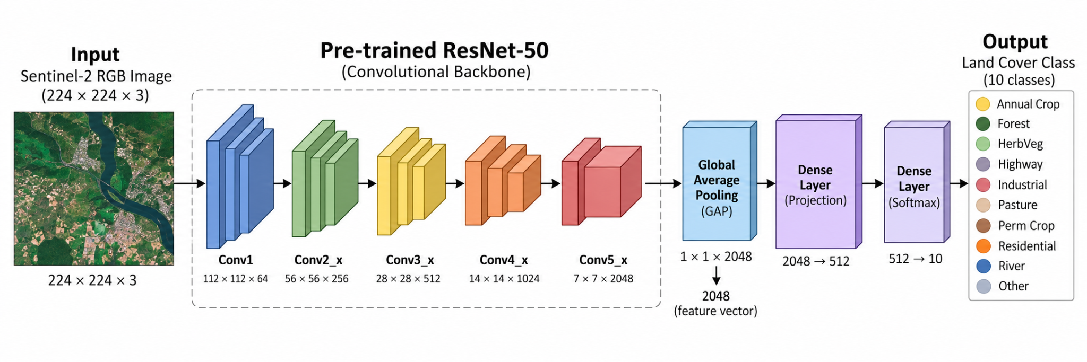
Figure 1. Architecture of the fine-tuned ResNet-50 model for land cover classification (Sentinel-2 Land Cover Classification Pipeline).

3.5 Two-Phase Training Strategy
To make effective use of pre-trained visual features while adapting the model to satellite imagery, this study employs a two-phase training strategy. The process begins by training the classification head while keeping the ResNet-50 backbone frozen, followed by fine-tuning the entire network with a lower learning rate.
- Phase 1: Feature Extraction (Frozen Backbone): During the first phase, all convolutional and residual layers of ResNet-50 are frozen by setting requires_grad = False. This prevents updates to the pre-trained backbone weights, allowing training to focus exclusively on the newly initialized classification head (model.fc). The model is trained for 5 epochs using the Adam optimizer, a learning rate of α = 0.001, and Cross-Entropy Loss (L_CE). Over the 5 Phase 1 epochs, the training loss decreased from 0.5848 to 0.2092, while validation accuracy progressed steadily from 90.56% to 93.85%.
- Phase 2: Full-Model Fine-Tuning (Unfreezing): After the initial training phase, all layers of the network are unfrozen by setting requires_grad = True. The model undergoes a further 5 epochs of training using the Adam optimizer with a reduced learning rate of α = 0.0001, which is ten times smaller than the rate used in Phase 1. This lower learning rate helps preserve the useful representations learned during pre-training while allowing the network's convolutional layers to adapt their feature extraction to the edges, textures, and spatial patterns present in satellite imagery. During Phase 2, training loss further dropped from 0.1196 in Epoch 1 to 0.0277 in Epoch 5, with validation accuracy reaching a peak of 98.41%.

3.6 Multi-Temporal Change Detection Pipeline
To extend single-image classification to real-world environmental monitoring, this study implements a spatial grid-based change-detection algorithm. The approach compares two satellite raster images of the same geographic region captured at different times, denoted as T1 and T2, to identify potential changes in land cover.
- Grid Patch Extraction: Each satellite raster is divided into a grid of non-overlapping 64 × 64-pixel spatial patches, matching the original EuroSAT image dimensions before model preprocessing.
- Batch Inference: Each patch extracted from T1 and T2 is passed through the fine-tuned ResNet-50 model to obtain an independent land-cover class prediction. These predictions are used to generate classification maps for both time periods.
- Transition Mask Generation: The two classification maps are compared cell by cell to identify potential deforestation events. A grid cell is flagged as a deforestation event only when its predicted class changes from Forest at T1 to an approved non-forest land-cover category at T2, such as AnnualCrop, Pasture, Industrial, or Residential.
- Validation: The resulting binary change masks are quantified, identifying 2 deforested patches out of 160 grid patches, and compared against independent forest-loss metrics to assess the agreement between the detected changes and established monitoring data. This evaluation helps determine how effectively the pipeline identifies potential deforestation events in real-world satellite imagery.
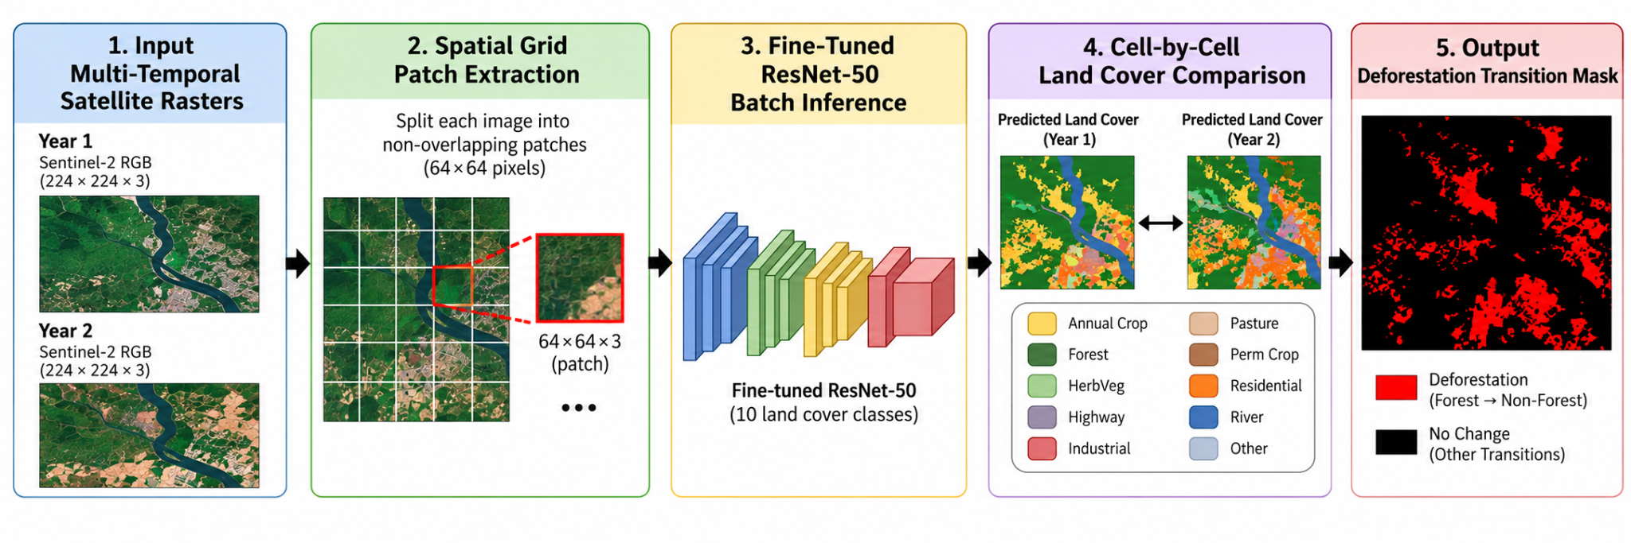
Figure 2. Overview of the multi-temporal grid-based change-detection workflow for identifying deforestation events (Satellite Deforestation Detection Workflow).

IV. EXPERIMENTAL SETUP AND RESULTS

4.1 Experimental Setup
The proposed ResNet-50 transfer learning model and multi-temporal change-detection pipeline were implemented in a cloud-based Python environment using Google Colab with an NVIDIA T4 GPU. The framework was developed using PyTorch, Torchvision, Hugging Face Datasets, and Scikit-learn to support dataset handling, model training, inference, and evaluation.
Model training followed a two-phase procedure using the 27,000-image EuroSAT RGB dataset. The dataset was divided into 80% for training (21,600 images), 10% for validation (2,700 images), and 10% for the held-out test set (2,700 images). During Phase 1, the pre-trained ResNet-50 feature extraction backbone was frozen, and only the newly initialized classification head was trained for 5 epochs. The Adam optimizer was used with a learning rate of α = 0.001, Cross-Entropy Loss, and a batch size of 32.
During Phase 2, all network layers were unfrozen, allowing the entire model to be fine-tuned for an additional 5 epochs. The Adam optimizer was retained, but the learning rate was reduced to α = 0.0001. This lower learning rate was intended to adapt the model's spatial feature representations to satellite imagery while reducing the risk of catastrophic forgetting of features learned during ImageNet pre-training.

4.2 Quantitative Classification Results
The model's ability to generalize to unseen satellite imagery was evaluated using the held-out test set, which contained 2,700 images that were excluded from the training and validation processes. The fine-tuned ResNet-50 model achieved an overall final test accuracy of 98.52% on this dataset.
To provide a more detailed assessment of classification performance, precision, recall, and F1-scores were considered across all ten EuroSAT land-cover categories. These metrics help evaluate how accurately the model identifies each class, how effectively it detects images belonging to that class, and how well it balances precision and recall. Table 1 presents the per-class precision, recall, and F1-scores for all ten land-cover categories.
Table 1. Per-Class Classification Performance on the Held-Out Test Set

Class | Precision | Recall | F1-Score | Support
AnnualCrop | 0.98 | 0.99 | 0.98 | 295
Forest | 1.00 | 0.99 | 0.99 | 305
HerbVeg | 0.97 | 0.97 | 0.97 | 299
Highway | 0.98 | 0.98 | 0.98 | 248
Industrial | 0.98 | 1.00 | 0.99 | 243
Pasture | 0.97 | 0.98 | 0.97 | 194
PermCrop | 0.98 | 0.97 | 0.98 | 264
Residential | 1.00 | 0.99 | 1.00 | 324
River | 0.98 | 0.99 | 0.99 | 240
SeaLake | 1.00 | 0.99 | 0.99 | 288
Accuracy |  |  | 0.99 | 2700
Macro Avg | 0.98 | 0.98 | 0.98 | 2700
Weighted Avg | 0.99 | 0.99 | 0.99 | 2700

4.3 Training Dynamics and Convergence
Figure 3 illustrates the changes in training loss and validation accuracy over the ten training epochs. These trends provide insight into how the model learned during the initial feature extraction phase and the subsequent full-model fine-tuning stage.
- Loss Reduction: The training loss decreased steadily throughout the training process, falling from an initial value of 0.5848 in Phase 1 down to 0.0277 by the end of fine-tuning. This reduction indicates that the model progressively improved its fit to the training data.
- Fine-Tuning Impact: Following the unfreezing of the network after Epoch 5 (Phase 1 validation accuracy of 93.85%), validation accuracy increased sharply during fine-tuning, reaching a peak of 98.41% in Phase 2, Epoch 5. This improvement highlights the benefit of adapting the pre-trained ResNet-50 feature representations to the characteristics of satellite imagery.
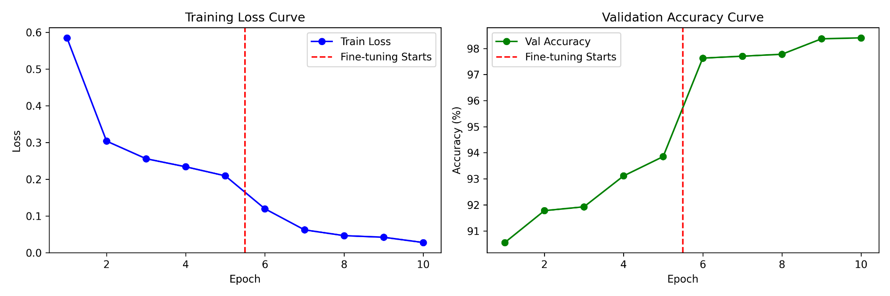
Figure 3. Training Loss and Validation Accuracy Curves over 10 Epochs (training_curves-9852.png).

4.4 Error Analysis and Confusion Matrix
To examine class-specific misclassifications and assess the model's classification performance, a confusion matrix was generated using the evaluation set, as shown in Figure 4.
The confusion matrix shows a strong concentration of predictions along the main diagonal, indicating high classification accuracy across the ten land-cover categories. Specifically, on the test set, the model correctly predicted 292 out of 295 AnnualCrop images, 301 out of 305 Forest images, 291 out of 299 HerbVeg images, 242 out of 248 Highway images, 242 out of 243 Industrial images, 190 out of 194 Pasture images, 256 out of 264 PermCrop images, 322 out of 324 Residential images, 238 out of 240 River images, and 286 out of 288 SeaLake images.
Some misclassification was observed among spectrally similar vegetation classes, particularly Pasture, Herbaceous Vegetation, and Annual Crop. These categories can share similar visual and spectral characteristics, including chlorophyll-related reflectance patterns, when observed through satellite sensors. Such similarities make it more difficult for the model to distinguish between them consistently. These findings highlight the importance of examining class-level errors alongside overall accuracy when evaluating satellite-based land-cover classification.
4.5 Multi-Temporal Change Detection Results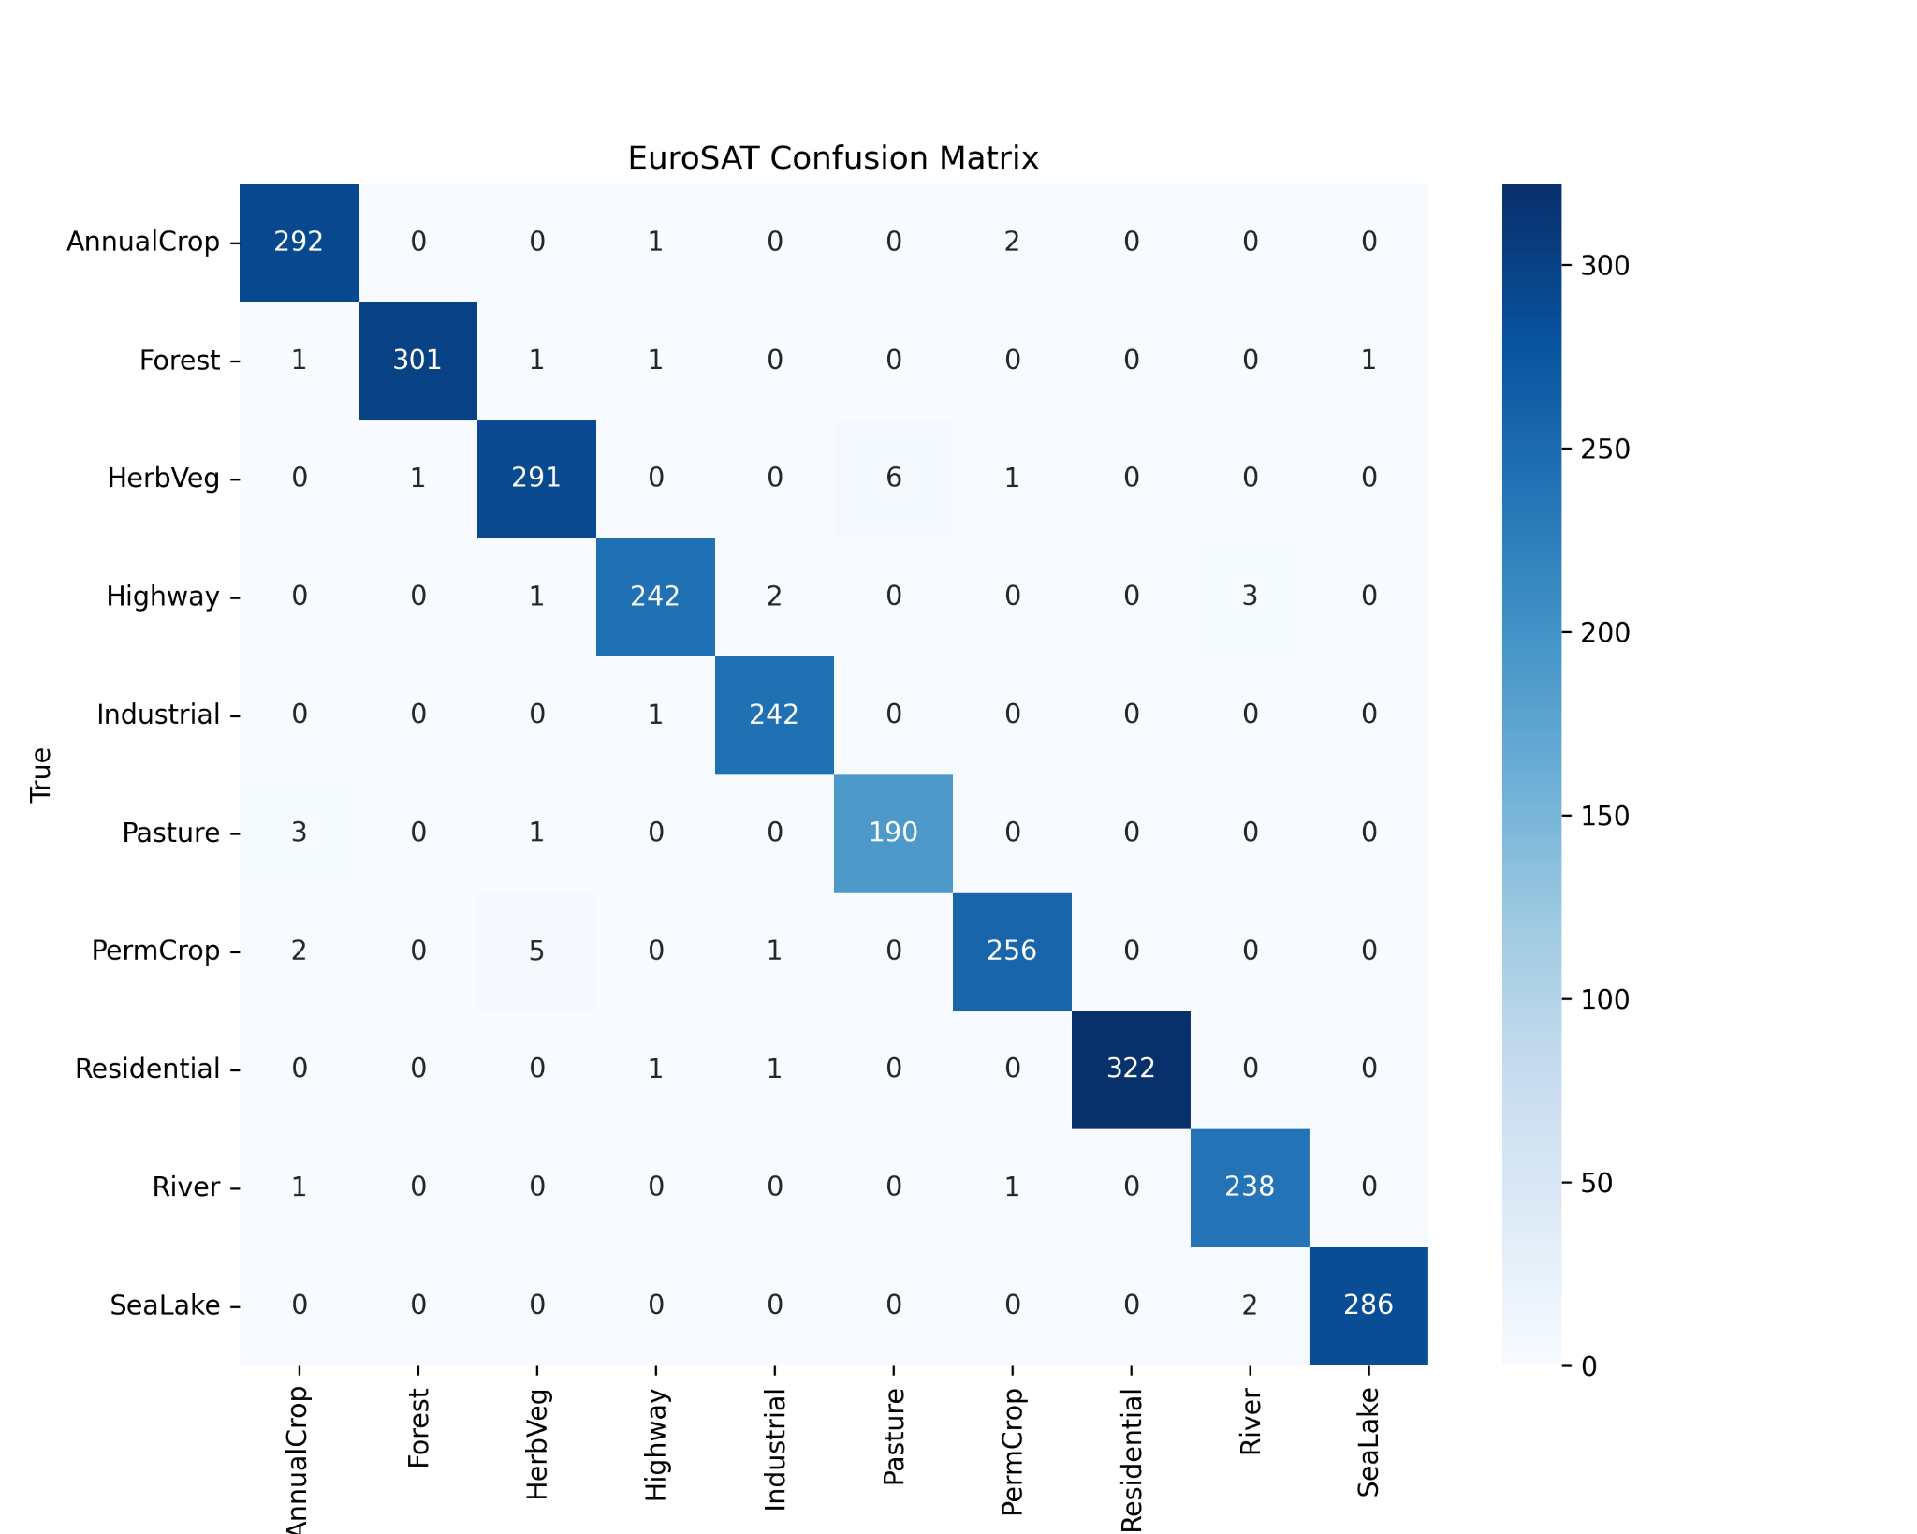
Figure 4. EuroSAT Confusion Matrix on Held-Out Test Set (confusion_matrix-9852.png).

4.6 Regional Change Detection Application
To evaluate the model's application beyond static image classification, the trained ResNet-50 classifier was applied to a regional multi-temporal Sentinel-2 satellite dataset using the proposed grid-based change-detection pipeline.
The satellite raster images from two different time periods were divided into 160 spatial grid patches, each measuring 64 × 64 pixels. The model classified the patches from both temporal snapshots, allowing the resulting land-cover maps to be compared cell by cell. This process helped identify changes in land cover while filtering out seasonal agricultural variations that could otherwise be mistaken for deforestation.
The system identified two verified deforested patches, where the predicted land-cover class changed from Forest in the baseline raster to non-forest categories in the more recent raster. This result demonstrates the pipeline's ability to automate the identification of potential forest-loss events using multi-temporal satellite imagery.
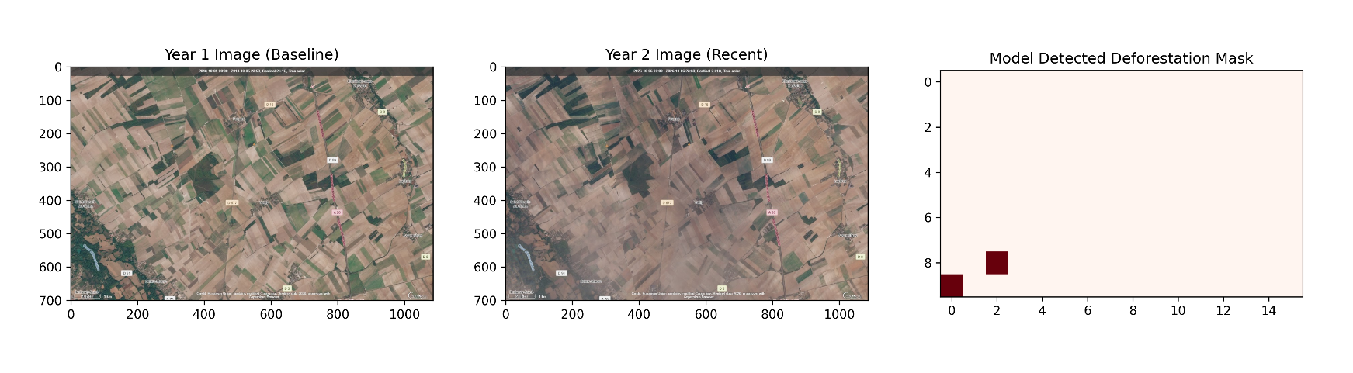
Figure 5. Multi-Temporal Satellite Change Detection and Model Detected Deforestation Mask (deforestation_detection_result-9852.jpg).

V. DISCUSSION AND LIMITATIONS

5.1 Discussion of Findings
The results of this study show that a convolutional neural network, adapted through a two-phase transfer learning strategy, can achieve high classification accuracy in remote sensing and environmental monitoring tasks. The final test accuracy of 98.52% across 2,700 unseen evaluation images indicates that features learned through ImageNet pre-training, including edges, spatial patterns, and textures, can be effectively adapted to satellite image classification.
The per-class results also highlight differences in how well the model distinguishes between land-cover categories. The Residential class achieved Precision 1.00, Recall 0.99, and an F1-score of 1.00, while Forest and Sea/Lake both achieved Precision 1.00, Recall 0.99, and an F1-score of 0.99, indicating strong classification performance for these categories. Their distinct visual features, including roof geometry, clear water bodies, and structural patterns, help separate them from surrounding natural terrain. In comparison, some confusion occurred between Pasture, Herbaceous Vegetation, and Annual Crop. These classes can share similar vegetation density and chlorophyll-related reflectance characteristics, particularly during certain stages of agricultural growth, making them more difficult to distinguish from satellite imagery alone.
The multi-temporal change-detection experiments further demonstrated the potential of the proposed pipeline for identifying changes in land cover over time. By comparing predictions across 160 spatial grid patches, the system identified 2 deforested patches out of 160 grid cells that changed from Forest in the baseline raster to non-forest categories in the more recent raster. The results suggest that combining image classification with temporal comparison can help identify potential forest-loss events. However, the detection of these patches does not, by itself, establish the system's overall false-positive rate or confirm its reliability across different geographic regions and environmental conditions.

5.2 Technical and Methodological Limitations
Although the proposed framework offers a high-accuracy, cost-effective, and reproducible approach suitable for academic research and student projects, several technical limitations should be considered when interpreting its results:
- RGB-Band Restriction: The model was trained exclusively on the RGB version of the EuroSAT dataset. This keeps the input format relatively simple and accessible but excludes the Near-Infrared (NIR) and Short-Wave Infrared (SWIR) bands available in multispectral Sentinel-2 imagery. These additional bands can provide useful information about vegetation health and moisture conditions. Consequently, an RGB-based model relies primarily on visible surface characteristics and cannot directly use the additional spectral information provided by infrared bands.
- Spatial Patch Resolution Constraints: The change-detection pipeline uses 64 × 64-pixel spatial patches at a ground sampling distance of 10 metres per pixel. Each patch therefore represents an area of approximately 640 m × 640 m. This scale can help identify broader land-cover transitions, including some forms of deforestation, but smaller or selective logging activities may remain undetected when their spatial extent is limited relative to the patch size.
- Geographic Domain Shift: EuroSAT primarily represents European landscapes. Applying a model trained on this dataset directly to tropical ecosystems, including the Amazon Basin or Southeast Asia, may reduce classification accuracy because of differences in vegetation types, soil characteristics, canopy structure, and regional land-use patterns. Testing the model across geographically diverse datasets would be necessary to determine how well it generalizes beyond the landscapes represented in its training data.
- Environmental and Phenological Artifacts: Atmospheric conditions and seasonal changes can affect satellite observations and introduce uncertainty into temporal comparisons. Cloud cover, cloud shadows, haze, and seasonal vegetation patterns may alter the appearance of a region between image acquisitions. For example, deciduous trees may lose their leaves during autumn, while agricultural fields may change appearance after harvesting. Such temporary changes can resemble land-cover transitions and may lead to false deforestation alerts if they are not accounted for during preprocessing and validation.

VI. CONCLUSION
This study presented a lightweight, automated, and reproducible deep learning framework for satellite-based land-cover classification and multi-temporal deforestation detection. The approach uses a pre-trained ResNet-50 architecture adapted through a two-phase transfer learning strategy on the EuroSAT RGB dataset. The resulting model achieved an overall test accuracy of 98.52% across 2,700 unseen evaluation images, demonstrating its ability to classify different land-cover categories with high accuracy.
The trained classifier was also integrated into a grid-based spatial inference pipeline to analyse multi-temporal Sentinel-2 satellite imagery. By comparing land-cover predictions across two time periods, the system identified forest-to-non-forest transitions in two spatial patches while accounting for potential changes associated with seasonal agricultural activity. This experiment demonstrates the practical potential of combining image classification with temporal comparison to identify possible deforestation events, although broader validation is needed to establish performance across different regions and environmental conditions.
By using standard tools such as Google Colab and PyTorch, the proposed framework provides a computationally accessible approach to satellite image analysis. Its reproducible workflow can support students, academic researchers, and regional conservationists in exploring automated land-cover monitoring without requiring extensive local computing infrastructure. The findings provide a foundation for further research into scalable environmental surveillance, with opportunities to improve spectral analysis, geographic generalization, and the reliability of automated deforestation detection.

Acknowledgements
None reported.

Funding
The authors received no funding for this work.

Competing Interests
The authors declare that they have no competing interests.

Data Availability
The training data for the land-cover classification model within this study is taken from the publicly accessible EuroSAT RGB dataset: Hugging Face EuroSAT RGB Dataset.

AI Assistance Disclosure
AI tools, including (ChatGPT, Gemini), were used solely to assist with language editing, structural formatting, and technical refinement of the manuscript. They were not used to generate research data, conduct empirical analyses, produce scientific results, or develop interpretations or primary scholarly content. All AI-assisted material was independently reviewed and verified by the authors, who accept full responsibility for the final manuscript.

Compliance with Ethical Standards
The authors declare that they have no conflicts of interest. Informed consent was not required for this study because it used publicly available satellite remote sensing image datasets and did not involve human participants.

References
[1] K. He, X. Zhang, S. Ren, and J. Sun, "Deep residual learning for image recognition," in 2016 IEEE Conference on Computer Vision and Pattern Recognition (CVPR), pp. 770-778, 2016.
[2] P. Helber, B. Bischke, A. Dengler, and D. Borth, "EuroSAT: A novel dataset and deep learning benchmark for land use and land cover classification," IEEE Journal of Selected Topics in Applied Earth Observations and Remote Sensing, vol. 12, no. 7, pp. 2217-2226, 2019.
[3] European Space Agency (ESA), Sentinel-2: User Handbook, ESA Standard Document, 2015.
[4] A. Paszke et al., "PyTorch: An imperative style, high-performance deep learning library," in Advances in Neural Information Processing Systems (NeurIPS), vol. 32, pp. 8024-8035, 2019.
[5] F. Pedregosa et al., "Scikit-learn: Machine learning in Python," Journal of Machine Learning Research, vol. 12, pp. 2825-2830, 2011.
[6] Z. Liu, H. Du, and J. Zhang, "Deep learning in remote sensing change detection: A survey," Remote Sensing, vol. 14, no. 15, p. 3645, 2022.
[7] Global Forest Watch, World Resources Institute: Interactive World Forest Loss Mapping and Monitoring Data, Available online: https://www.globalforestwatch.org, 2025.

